SCRAP Advisory Group

Agenda – January 8, 2020

CCS Office, 9:30 am

Review upcoming usability testing for multivolume vs single records. (30 minutes, K. Weiss)
ACTION: Discussion.
K. Weiss reviewed the next round of usability testing which will focus on patron’s ease with finding graphic novel issues using multivolume vs single records. K. Weiss expects to have testing completed by March with results available by April or May. The results will be sent to CAMM to help them make the most informed decision on moving forward.

Update on PAS feedback for award nominee information. (15 minutes)
  - Review of PAS discussion at Dec. 2019 meeting

PAS would like to have 2 separate record sets – one for the previous year and one for the new year. Libraries are making their decisions based on how their school districts use the lists. There will be a year in the name of the record set. Each library will need to choose the record set that they want their PowerPac carousels to point to.

  - Schedule/assign record set updates for:
    - Monarch – Calah (HUK)
    - Bluestem – Jamie (NIK)
    - Rebecca Caudill (Virginia)
    - Lincoln -- DPK
ACTION: Discussion and set assignments.

3. TOMs for Playaway Wonderbooks (30 minutes)
- As discussed at 11/19 CAMM meeting, the preferred TOM for Wonderbooks is Sound recording. Review draft entry for the Wiki. Request to consider wiki entries for Launchpad and Playaway View as well.
ACTION: Discussion.
SCRAP determined that “audiobooks” is the preferred term because it is more specific than “sound recording”. Also the icon in the catalog for audiobook has a picture of a book. Debra will create a draft wiki entry. Launchpad and Playaway View have wiki entries. This topic will be discussed at the February CAMM meeting.

4. Subject Heading Discussion: Illegal Aliens (20 minutes)
- Overview of issue and review of PAS slides.
ACTION: Discussion
“Illegal aliens” is the LCSH authorized heading. There has been a national conversation on whether this heading is non-inclusive. Some libraries/systems have developed local practices to replace this heading. Most of the CCS PAS technical group is in favor of CCS using a different heading, even if it means creating a local heading. There is not a consensus on the preferred heading.
ALA has created a working group to review the current heading and issue a recommendation. Their recommendation may be available in February. CCS will wait to hear the decision of the ALA working group before moving forward.

5. Library of Things (15 minutes)
  - Discuss current cataloging practices
    - Preference for OCLC records?
    - Separate records or shared?
Libraries have done their own thing with these items. Some libraries create OCLC records and some use local records only. Libraries will share a record in cases where the item is the same. At this time, SCRAP will not create an overarching procedure. A Library of Things entry will be added to the wiki.

6. Travel guides: 245|p vs 490/8XX (15 minutes)
  - Example: Bib control 2125284
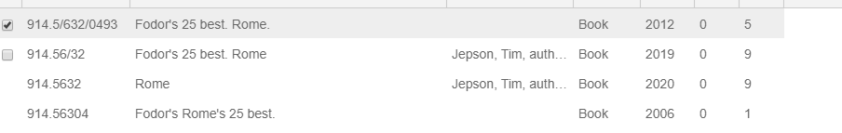
Because we are now using monograph records for travel books instead of adding to a series, there is inconsistency in how titles show up in the LEAP hit list. In the above example, the series is in the 245 for the 1st, 2nd and 4th entries. In the 3rd entry, the series name is in the 490 and 246 but not the 245. It’s clearer in the PowerPac because the series name is listed in the hit list. The consensus of the group seemed to be a preference for the series name to be in the 245.
CCS will present at next PAS meeting on searching for travel guides and create documentation for searching as needed. CCS will update the wiki page to say that we prefer consistency in the format of the 245 for titles within the same series for standalone records.

7. Former local practice of 347$b Playaway (10 minutes)
The 6.4 update will be released later this month. It is hoped that a “Playaway” type of material will be one of the new TOMs that is available. This item is being tabled until the April 2020 SCRAP meeting.

8. February CAMM meeting
Reviewed topics that will be added to the February agenda.

