Proposed updates are in RED.

Re-Registering or Updating a Patron
Not all situations require creating a new library account. A patron may have an existing CCS library account but has moved into your service area. Or, the patron is already a resident but has misplaced their card and requires a new barcode. In these situations, the patron should be RE-REGISTERD under their existing account. Other times, the patron does not need a new barcode, but rather just needs some of their account information updated – for example, they received a new phone number. In these situations, staff can just UPDATE the existing account with the corrected information.

Re-Registering a Patron
There will be times when a patron may come in for a library card and you find they already have a record in the database. These situations may include:
- The patron’s card is lost or was stolen and needs to be replaced with a new card.
- The patron has moved to your library service area from a different CCS library.

In these situations, do not create a new record. Instead, update the existing record with the corrected information.
- Open a patron’s account.
- Resolve any outstanding fees or delinquencies. If the patron is a new resident of your library service area, follow local procedure for verifying the new address.
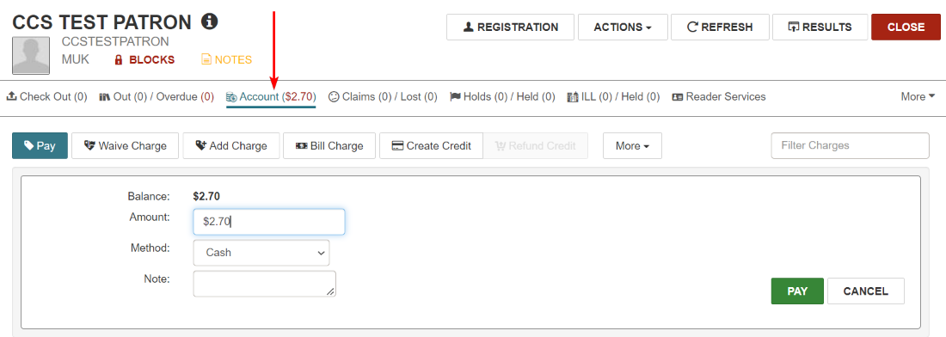

- Select Registration.
- Update all necessary information, such as their address and contact information.
  - If re-registering the patron from an existing CCS library record, make sure to update the Registered At, Patron Code, Statistical Class Code (if needed), and ILL/RB Library Code fields to reflect local settings.
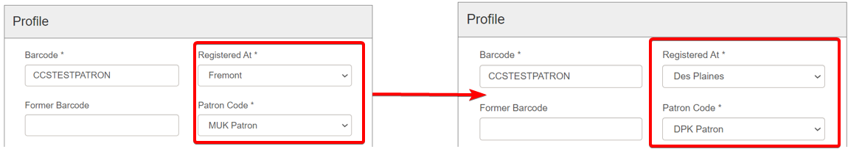
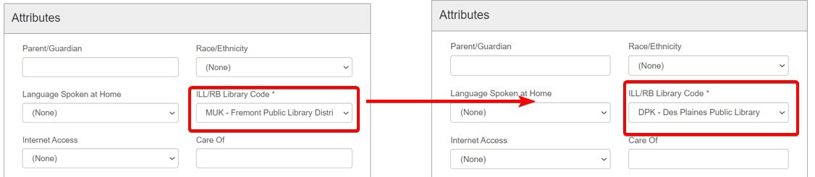
  - Update the Expiration Date and Address Check Date as appropriate.
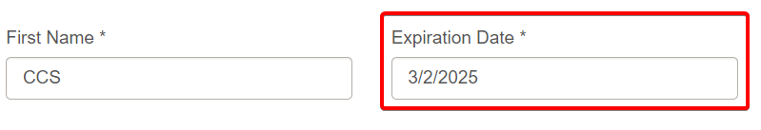
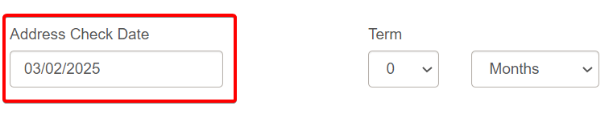
  - Copy-and-paste their old barcode into the Former Barcode field before scanning the new card number.
While the Former Barcode field is searchable using the Find Tool, it does not transmit via SIP and cannot be used at a self-check or be used to authenticate users online. However, patrons who use ebook services may need to have their former barcode retained in order to merge ebook vendor accounts.
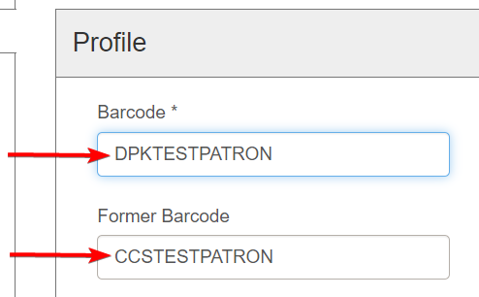
  - For users reviewed by NCOA: If the user has a “PrevHome” address field and has verified their new address, delete the “PrevHome” address field.
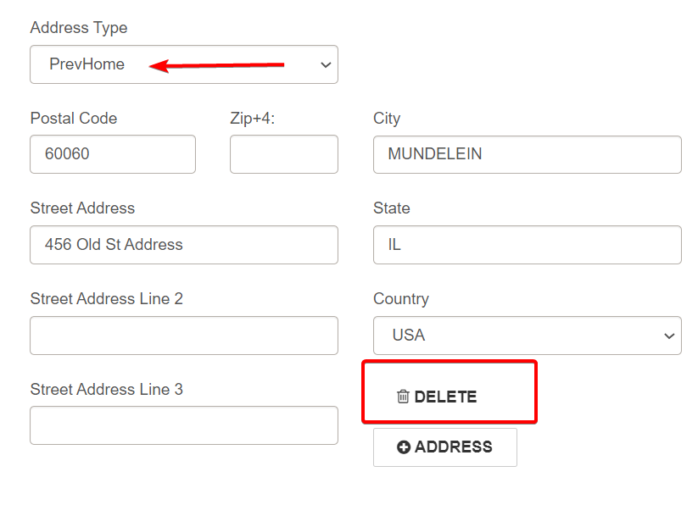
- Click Save to save any changes.
- Double-check for blocks and/or notes that need to be removed.
  - For users reviewed by NCOA: if the user has an “Invalid Address-NCOA" block and has verified their new home address, delete the “Invalid Address-NCOA" block.
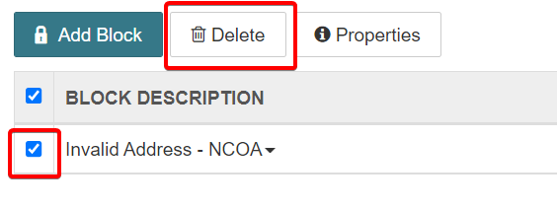
  - For users reviewed by NCOA: if the user has a “[mm/dd/yyyy/CCS New address returned via NCOA” note and has verified their new home address, remove the NCOA note. Click Update Notes to save the changes.
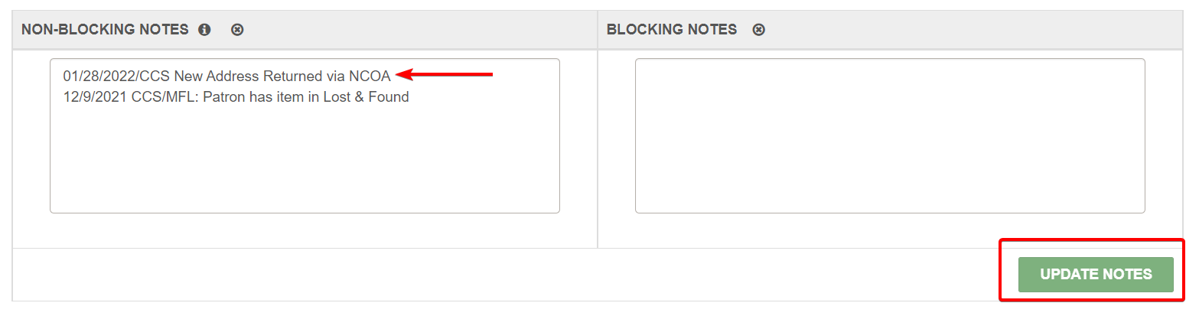

Updating Patron Records
In other situations, the patron may not need a new card number, but instead just needs to update some information in their record. Some examples of these situations may include: a name change or updating contact information.

Staff may make any updates needed to local patron accounts (or, patrons registered to their own library) and non-CCS reciprocal borrower accounts.

If the user is registered to a different CCS library than your own, staff may update:
- Phone numbers
- Email
- Notification option
- Language
- Password
Changes to any other fields (such as address) must be done by the patron’s home library.

