Lost & Paid ILL Procedures

Background
ILL requests will remain on a patron’s record until the ILL item is checked in and the request marked as returned and deleted. All actions are tied to the ILL request record; the ILL item record cannot itself be deleted. However, staff can only mark an ILL request as returned if the associated item is “Available.” As a result, staff are unable to modify the ILL request record if the item becomes Lost.
The draft procedures provide instruction on how to manage a lost and paid ILL item.

Proposed Draft Procedures
Removing Lost & Paid ILL Requests (DRAFT)
After the replacement fees for an ILL item are paid or waived, the ILL request record will have a status of “Received” and the ILL item a status of “Lost.”
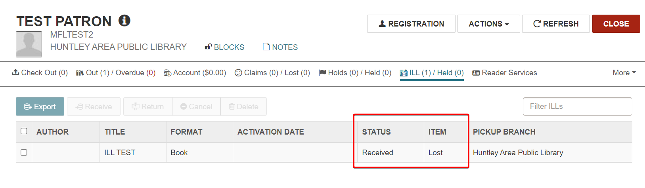
To remove the ILL request record and mark the ILL item record for deletion:
- Check the ILL item in. Copy-and-paste or key in the item barcode in the Check In workform.
- Click continue through any block messages.
- When presented with the Resolve Lost Item dialogue box, select “Leave as is” for relevant actions. (Do not click Refund or Credit.) Click “Continue.”
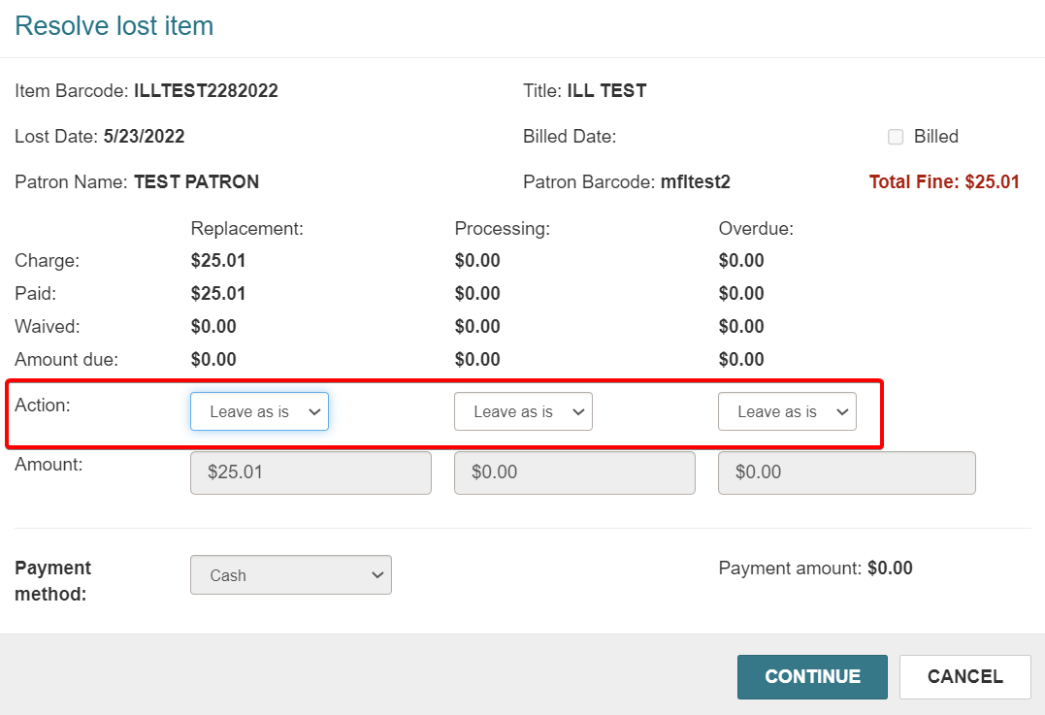

At this point, the ILL request record status is “Received”, and the ILL item status is “Available.”
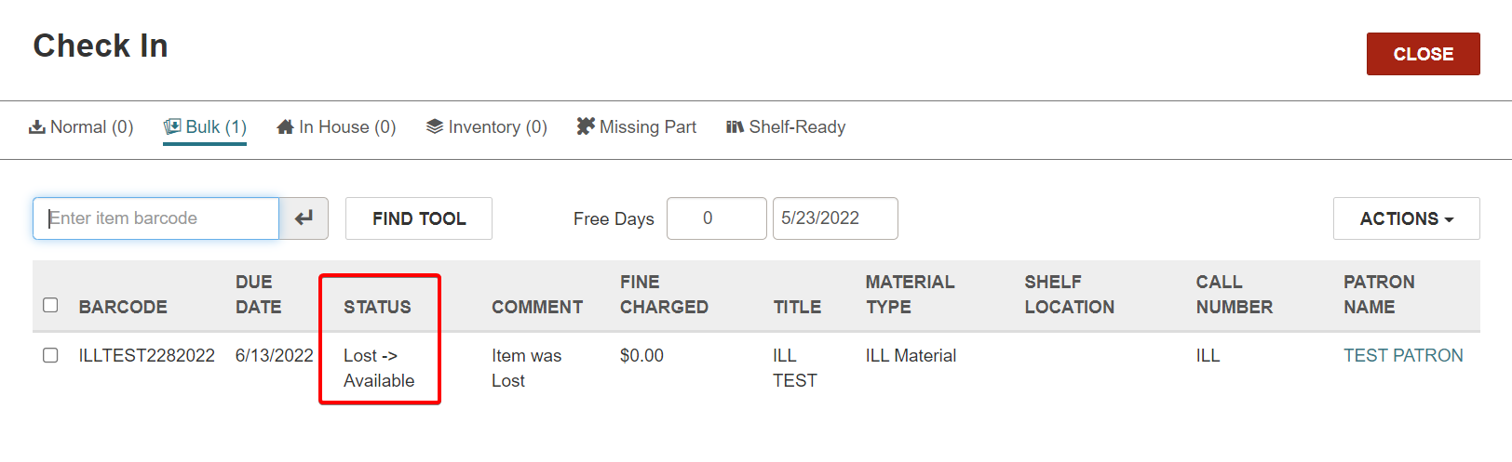
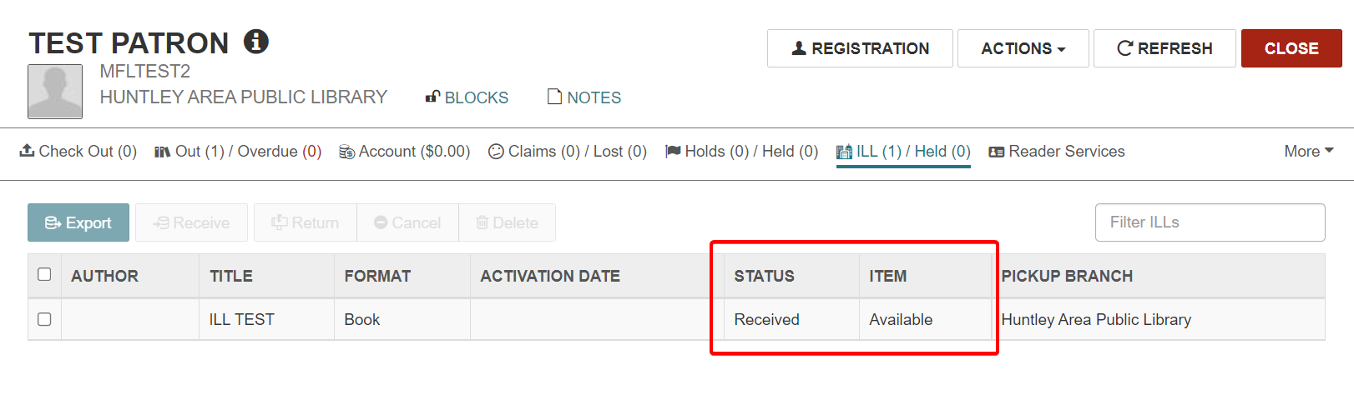
- From the Request Manager or the patron’s record, locate the ILL request. Select the request and click “Return.”
- The ILL request record now has a status of “Returned.” Select the request again and click “Delete.”
The ILL request record will be permanently removed from the database and the ILL item marked as deleted.

