CCS Circulation Technical Group

July 14, 2023 Meeting Action Items

7.4 Setting Change: Canceling Holds in Held Status
At this time, staff and patrons can cancel only certain types of holds in Leap or the PowerPAC. This includes holds with a status of Requested, Paused, Locating, or Shipped. If a request is in Held status (Ready-for-Pickup), staff can only cancel the hold by checking the held item in. The patron is not able to cancel a Held request from the PowerPAC.
A new Polaris setting allows patrons and staff to cancel Held holds in the PowerPAC or Leap. Patrons will see a warning and a prompt to confirm cancelation in order to complete the action. This setting only applies to intra-CCS holds; it does not apply to out-of-system ILL requests.
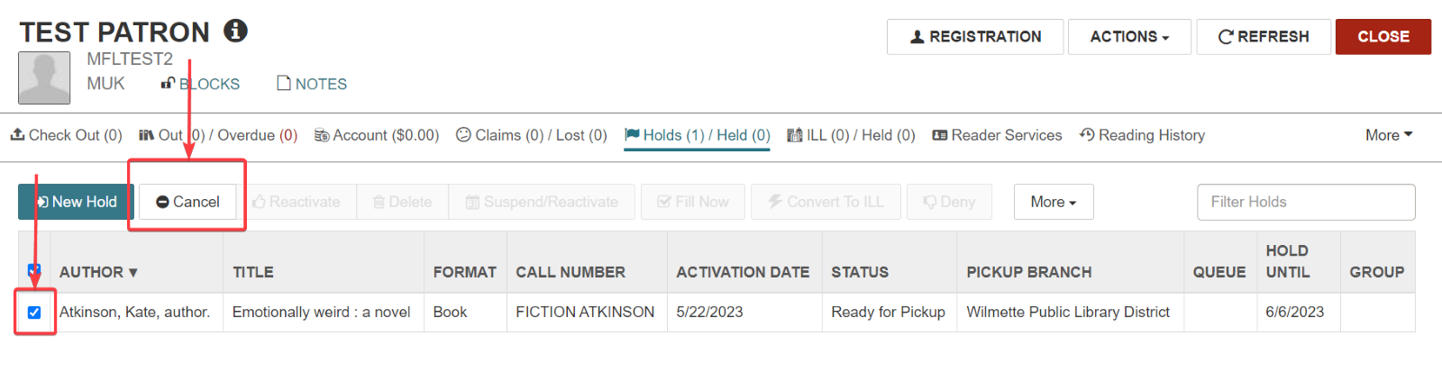
Cancel Held hold in Leap

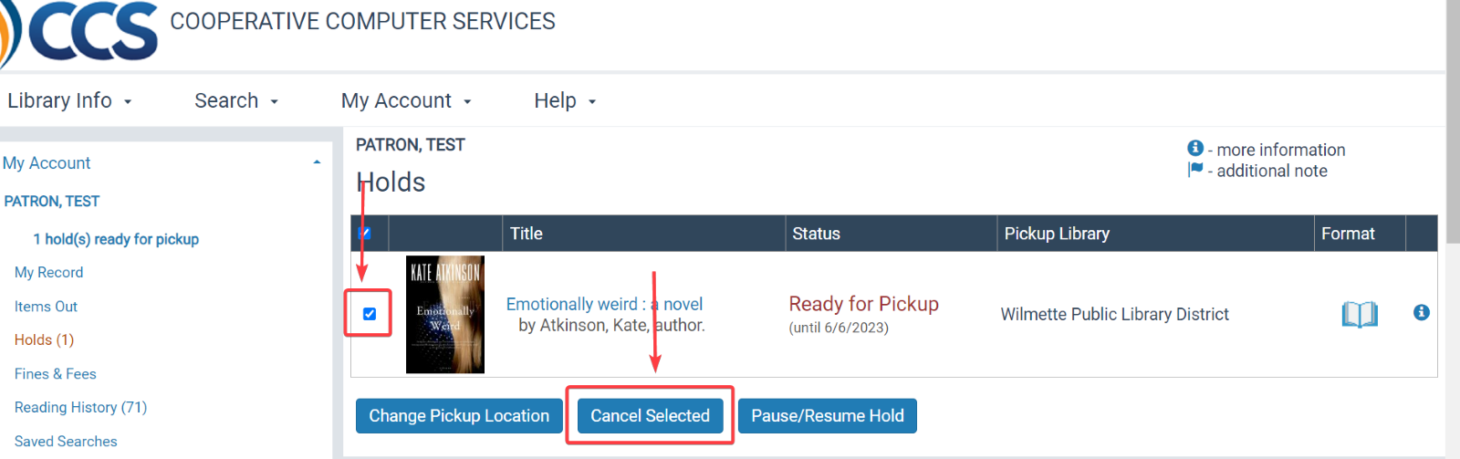
Cancel Held hold in PowerPAC

Any Held holds that are canceled are added to the Picklist under a “Canceled” view or a “Holds to Action” view, depending on settings. The canceled hold will also appear in the Daily Clean Hold Shelf Web Report. This allows staff to identify canceled holds that need to be pulled from the hold shelf and checked in. Just like holds in an Unclaimed status, the canceled hold will maintain a status of Canceled and will appear in this Picklist tab until staff check the item in.
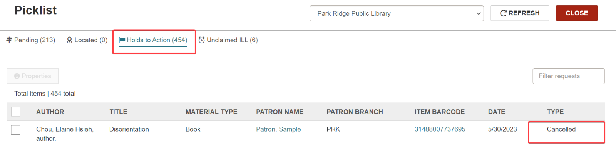
Identifying canceled Held holds

Proposed motion: Enable staff and patrons to cancel hold requests in Held status.

7.4 Setting Change: Combined Picklist View
The Leap Picklist organizes holds to pull based on hold status, which includes Unclaimed intra-CCS holds and unclaimed ILL, Ready for Pickup holds that need to be transferred to a new pickup location, and (as of 7.4) Canceled holds. For each of these tabs, staff are expected to pull the hold from the hold shelf and check the item in.
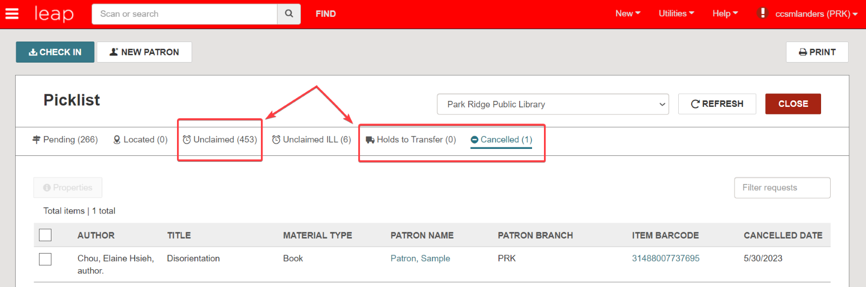
Default Picklist tab view

A new Picklist setting enables a combined view, where Unclaimed intra-CCS holds, Holds to Transfer, and Canceled holds are all listed together under a “Holds to Action” tab. This setting is optional.
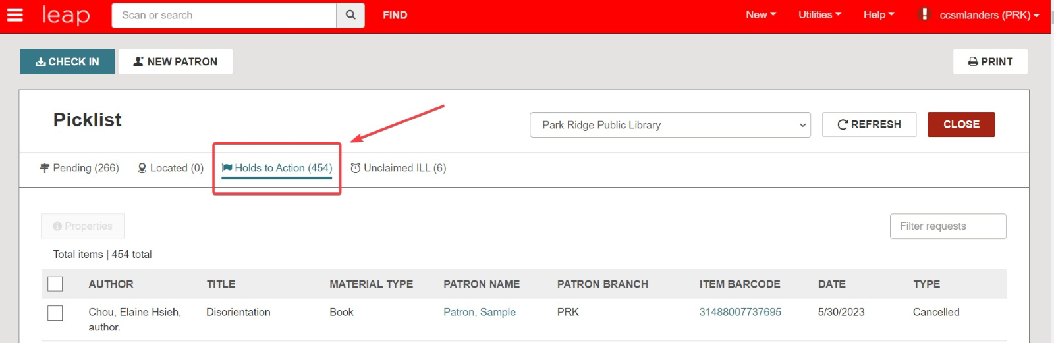
Combined Picklist “Holds to Action” view

The combined picklist view includes a “Type” column which will list if the hold is unclaimed, canceled, or is a transfer.
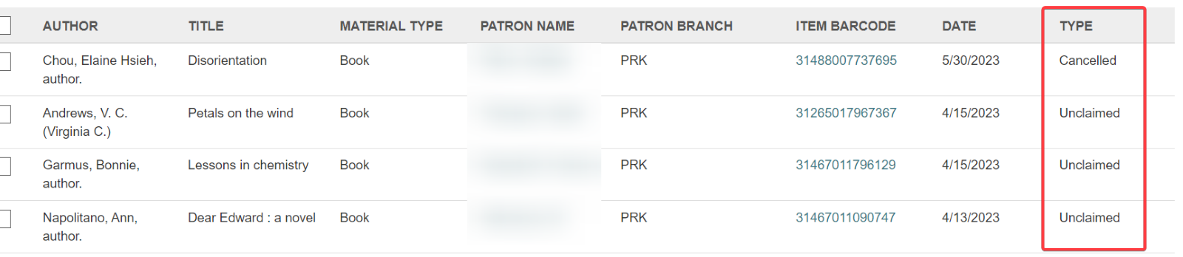
Proposed motion: Enable the combined Picklist holds view in Leap.

