Circulation Technical Group

Action Items – October 13, 2023

Patron Record Single Name Only

Background
By default, Polaris requires both a first name and a last name to save a patron record. People are required to have both a first and last name on file, even if from a mononym culture. Institutions, such as businesses and schools, may have their name divided between the first name field and the last name field or use filler characters for one of the fields.

Single Name Only Setting
A new setting in Polaris gives the option to only require a last name field. If enabled, staff will be able to save a patron record without entering a first name.
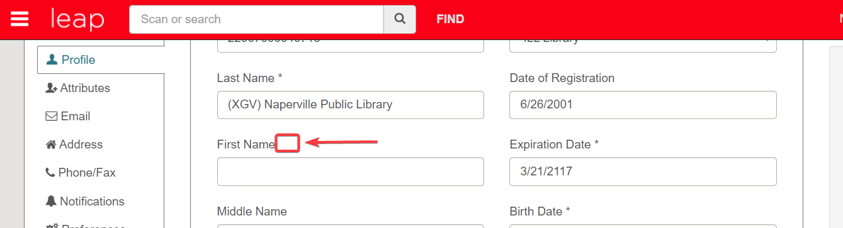
First name not required

When registering a patron with a single name, staff would select the “Use Single Name Field” checkbox in the patron registration workform. When selected, Leap will disable the first name and middle name fields. This serves as an indicator that using a last name only was an intentional decision.
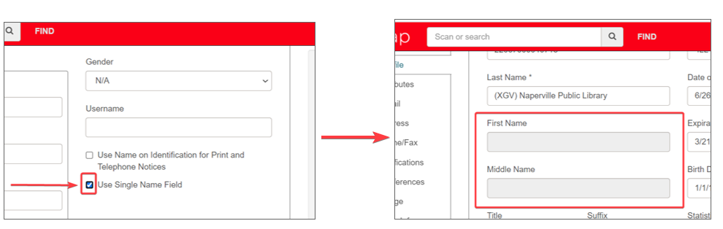
Use Single Name Field checkbox

If “Use Single Name Field” is not checked and staff only enter a last name, a “No first name entered” pop-up alert will appear when the record is saved
.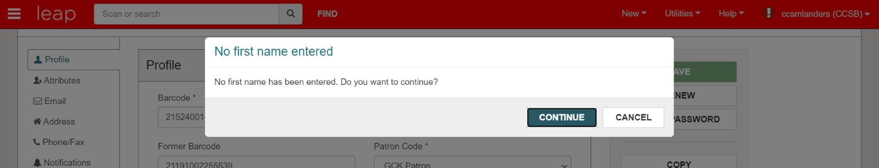
No first name entered alert

As of Polaris 7.4, the patron Last Name Field can now hold up to 100 characters in order to support longer names, such as a business or school name.

Searching
The Leap Quick Search Box will search for first name, middle name, last name, first-middle-last name, or last-first-middle name. Staff will be able to search for patrons that use a single name only.

If searching using the Leap Find Tool, staff can choose to search All keyword fields, Name (Last, first middle), or Name (First middle last) to locate patrons that use a single name only.

Reports
When generating a Simply Report, Web Report, or Staff Client report, patron last name data will appear in patron last name or patron full name output. Staff will not see data in first name only output if a patron only uses a last name.

Bulk Updates on Existing Patrons
Libraries may currently employ different practices for inputting mononym and institutional names. A global update to single field names for these users would not be viable. CCS would work individually with libraries who are interested in bulk updates to determine options for name fields.

Circulation/ILL Advisory Group Recommendation
The Circulation/ILL Advisory Group recommends enabling the single name only setting for CCS library branches.

PROPOSED ACTION
Motion to enable single name only for CCS library branches.

MessageBee Automated Non-Blocking Note for Bounces

Background
CCS libraries began using Unique’s MessageBee text messaging services in August 2023. MessageBee will track bounced notices. Staff can view bounces through the MessageBee portal or by setting up an emailed report.
CCS libraries have undeliverable message procedures, including bounced text notices. These procedures include adjusting the patron’s notice preference to email or phone and adding a non-blocking note.

Automated Non-Blocking Note Option
MessageBee supports an option to add a non-blocking note to the patron’s record if it detects a bounced message. The non-blocking note text would say:
“[DATE] – Notification to [###-###-####] bounced."

Circulation/ILL Advisory Group Recommendation
The Circulation/ILL Advisory Group recommends enabling the MessageBee automated non-blocking note.
Note About the Recommendation
The recommendation was made under the assumption the non-blocking note can be prepended to the note field. Confirmation that the non-blocking note can be prepended is pending from MessageBee, and we may not have a definitive answer until later in October. The proposed motion may be modified to specify to enable only if a note can be prepended, pending group discussion.

PROPOSED ACTION
Motion to enable the MessageBee non-blocking note.

