Minutes
CCS Circulation Technical Group
Live via Zoom
January 19, 2024
9:31 a.m. – 10:45 a.m.

Vice Chair Dana Jenkins (Des Plaines) called the meeting to order at 9:31 a.m.

Attendees
Apisara Houltram (Algonquin), Cheryl Allen (Cary), Julie Gibson (Crystal Lake), Mari Swift (Crystal Lake), Johne Lavalie (Des Plaines), Michelle Meyer-Edley (Des Plaines), Dana Jenkins (Des Plaines), Gabriela Mansera (Evanston), Keri Carroll (Fox River Valley), Karen Bolton (Fremont), Karen Kee (Glenview), Meredith Bernhardt (Grayslake), Jana Crabtree (Grayslake), Danny Quinlan (Highland Park), Donna Ramierz (Indian Trails), Tori Sergel (Lake Forest), Lynn Firman (Lake Villa), Stephanie Haugan (Lincolnwood), Brent Michalski (McHenry), Gregory Alexander (Morton Grove), Janine Wisniewski (Mount Prospect), Karen Bollman (Palatine), Jennifer Sobel (Palatine), Rosalie Scarpelli (Palatine), Lou Ocampo (Palentine), Anastasia Rachmaciej (Park Ridge), Alisha Smaby (Round Lake), Jian Rao (Round Lake), Marilyn McClelland (Waukegan), Matthew Hoffman (Wilmette), Kathryn Freemond (Winnetka-Northfield), Paula Pavelski (Zion-Benton), Mieko Fujiura-Landers (CCS)

Approval of minutes from the October 13, 2023 CCS Circulation Technical Group Meeting
Donna Ramirez (Indian Trails) made a
Motion: to approve the minutes of the October 13, 2023 Circulation Technical Group Meeting
Michelle Meyer-Edley (Des Plaines) seconded the motion
Motion passed

Additions to the agenda
Donna Ramirez (Indian Trails)
- delivery from rails this morning
Karen Kee (Glenview)
- policy for bugs and lice on books

Officer reports
Chair: Athena Crouse (Niles)
- absent
Vice Chair: Dana Jenkins (Des Plaines)
- none
Secretary: Anastasia Rachmaciej (Park Ridge)
- none

CCS staff reports
Updates from M. Fujiura-Landers
- Posting link to the meeting sign
- CCS Updates
  - Polaris upgrade to 7.5 scheduled for 10 pm Monday, February 26
  - Update to the survey on age-restricted materials from November
    - In addition to the ILS settings in 7.5 there is a new feature that would allow us to add an age rule to checkouts based on material types. For example, a patron could only checkout a laptop 16 age or older. Polaris would look at the patron’s birthday on the patron record to determine if checkout is allowed. We thought this may be a feature that some libraries were interested in exploring. Unfortunately, after exploring in the test server, CCS discovered this is a system-level setting and will not work in a consortium environment. CCS will hold on to the survey responses in case functionality changes in the future.
  - Mount Prospect-Waukegan migration- Go Live on Tuesday, October 1
    - CCS anticipates an offline period of 3-5
    - Tentative offline date is September 28.
- Circulation distribution emails are ready to use!
  - Staff can begin using them today
  - List of distribution email addresses is available on our website- how to > Department- Public Services > Circulation
  - Going forward if you would like to add or remove contacts from the distribution list, open a help desk ticket with CCS
- Patron record clean up: in-house use cards
  - Web reports excludes use stats from patron code In-House Use
  - Clean up activity: check patron records with stat class “In-House Use” and verify they have patron code “In-House Use”
  - Use Leap Find Tool- search patron records by statistical class= in-house use or use Monthly Record Counts by Patron Characteristics Web Report > Patron Code and Statistical Class
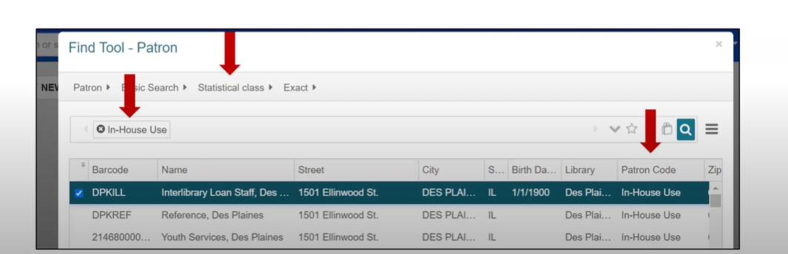

Leap Find Tool

Web Reports
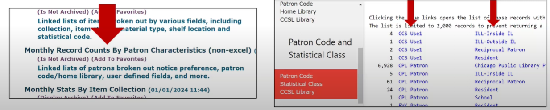

Updates from D. Wischmeyer
absent

Old Business
None

New Business

7.5 Leap Functionality for Damaged Circulation Status (ACTION)
Setting an item to “Damaged” currently requires an item to be checked in/available and for staff to manually change circulation status and/or apply fees. Limitations are based on staff permissions and item assigned branch. The 7.5 version of Leap will include new functions for setting an item's circulation status to "damaged."

New damaged item-related functionality in Polaris 7.5 would allow staff to declare an item damaged from check in or the patron account to:

- change item circulation status to “damaged”
- add block to item record
- (Optionally) charge replacement fee, processing fee to patron account
- (Optionally) generate manual bill notice for item

If adopted, libraries who prefer to set items to "damaged" status will have several options for doing so based on the situation you're dealing with. (Libraries who prefer to mark damaged items as "Lost" may continue to do so!) Additionally, if adopted, we would then be able to re-use the current "damaged" circulation status for a different purpose.
Mieko demoed two workflows on how to utilize the new damaged circulation status.
From check in screen, select the “damaged” tab. Scan barcode and the select either:
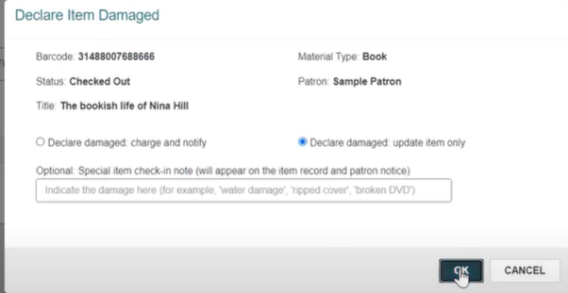
- Declare damaged: charge and notify patron 2. Declare damaged: update item record only

7.5 Leap Functionality for Damaged Circulation Status
- Fees applied using Declare Damaged will automatically qualify for collections submission
- Adopting functionality would free up current “Damaged” circ status for other use
- If adopted, Web Reports would not change- reports that include Damaged item information will continue to do so
Why do we need to decide between current way and new functionality?
- New functionality comes with built-in circulation status, separate from existing circ status
- If using both current and new, will need to manage two separate “Damaged” circulation statuses
How-to page (link to draft)

Julie Gibson (Crystal Lake) made a
Motion: to enable LEAP functionality for Damaged Circulation Status
Karen Kee (Glenview) seconded the motion
Motion passed

Revisions to Damaged Procedures (ACTION)

With the approval of the use of the damage functionality, updates to CCS damaged procedures are needed since there were references to the old procedure.

Revision to Damaged Procedures
- Revisions separate the how-to from the procedure where possible
- Damaged procedures focus on when to apply local procedure, when to work with another library, and expectations in those situations, then direct staff to relevant how-to as needed
- Intent is that this division will allow us to address new Leap functionality separate from procedures if needed in the future
Summary of clarifying language added:
- In the “Summary” section-clarifying that blocks and blocking notes can be added to local and reciprocal patrons, as per the Circulation Manual
- In the “A Note About Fees” section- referencing Governing Board Policy
- In the “A Note About Fees” section- clarifying application of processing fees

Revised procedures

Julie Gibson (Crystal Lake) made a
Motion: to revise the CCS Damaged Procedure
Tori Sergel (Lake Forest) seconded the motion
Motion passed

Leap Settings Tips - M. Fujiura-Landers/CCS (Presentation)

Mieko demoed various search and configuration settings.

Additions to the agenda
Donna Ramirez (Indian Trails)
- Indian Trails received 6 bins from RAILS delivery that were soaking wet. Was able to save most library items but a few were not salvageable and owning libraries were notified.
Karen Kee (Glenview)
- Karen asked the group if anyone has any guidelines or polices to share regarding bug infestations.

Adjournment
Karen Bolton (Fremont) made a
Motion: to adjourn the meeting
Karen Kee (Glenview) seconded the motion
Motion passed

Meeting adjourned at 10:45 a.m.

Next Meeting
Friday, April 12, 2024
9:30am-11:30am
In Person-CCS OFFICE
100 Tri-State International Drive, Suite 122, Lincolnshire, IL 60069

