# Patron Record Title Field (ACTION)

**Potential Action**  
Motion to cease use of the patron record title field.

**Background**  
The patron title field is an optional name-related field in the patron registration workform where staff can select name prefixes from a pre-defined list. This list is configured at the system-level is shared by all CCS libraries – it cannot be edited or scoped at the branch level.

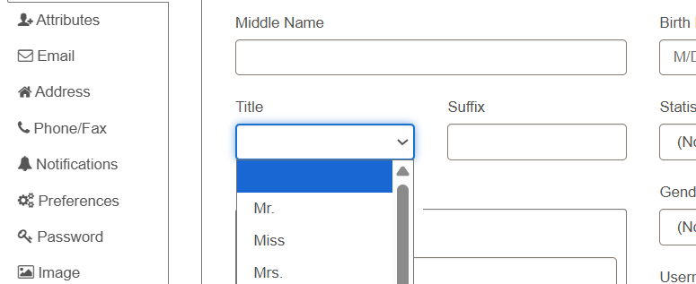

*Patron Registration Workform Title Field*

Additionally, while the Title field itself cannot be suppressed from view, individual list entries can be modified or removed.

As of July 3, 2025, 5,210 patron records include title information (or, 0.89% of patron records include title information). 574,207 or 99.1% of patron records do not have title information. Less than 30 patrons registered since 2020 have Title information in their record.

The table below lists the title options and the number of patrons using the title(s).

|  |  |
| --- | --- |
| **Title** | **No. Patrons Assigned** |
| *No title used* | 574207 |
| Ms. / Ms | 2536 |
| Mr. / Mr | 1506 |
| Miss | 444 |
| Mrs. / Mrs | 666 |
| Dr. / Dr | 24 |
| Jr. / Jr | 19 |
| Sr. / Sr | 10 |
| III | 3 |
| IV | 1 |
| (S) / s | 1 |
| Capt | 0 |
| Fr. | 0 |
| Hunk | 0 |
| MD | 0 |
| NTR | 0 |
| o | 0 |
| Rev. / Rev | 0 |
| Sstr | 0 |
| St | 0 |
| ; | 0 |
| = | 0 |
| Test | 0 |
| WLK | 0 |

The origin of the Title list options is unclear. The list includes redundancies (for example, ‘Mr.’ and ‘Mr’ are listed as separate entries), name suffixes (Jr, Sr, III), and unknown entries (o, =). Additionally, several entries are gender-specific (Miss, Mrs., Mr.) and the list does not include gender-neutral options such as Mx.

**Visibility of Title Field Data**  
Polaris Title Field data is visible/accessible:

* In the patron registration workform in Leap/Client
* In Simply Reports
* On notices
* Transmitted via API (per PAPI 7.7 reference guide)
* In the Find Tool (via name field)
* Via SQL queries

Polaris Title Field data is not visible/accessible:

* Not transmitted via SIP or included in SIP name field
* In patron’s PAC account
* When trapping holds or on hold wrappers

**Circulation/ILL Advisory Group Recommendation**  
The Circulation/ILL Advisory Group discussed the purpose and use of the Title field at both their December 2024 and June 2025 meetings. The committee recommends CCS libraries cease use of the Title field. If the recommendation passes, CCS will remove all options from the drop-down list and clear existing data or (if appropriate) move to the Suffix field.